Of Mice and Men Pre-Reading:
What Is Your American Dream?
Think back to The Great Gatsby and how all of the characters interpreted the American Dream in the 1920s. Similarly, the characters in Of Mice and Men have their own ideas about the American Dream during the Great Depression. Before reading, think about your goals and aspirations by answering the following questions:
List three goals or dreams you would like to accomplish before the age of thirty.
Ms. Herda’s Example: I hope to attain my master’s degree.

List three goals or dreams you would like to accomplish before you die.
Ms. Herda’s Example: I hope to publish a book.

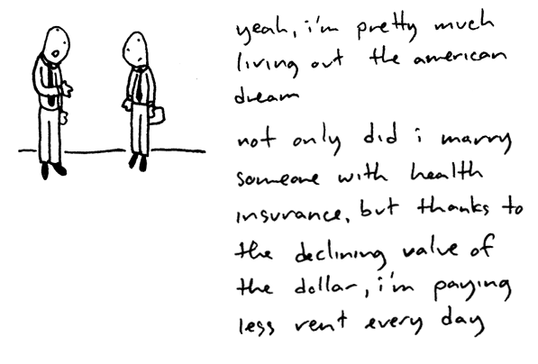
Are your dreams similar/different to the literary characters we have read about? Of the above goals and dreams, which are most important to you? How will you fulfill these dreams? What are you currently doing to insure your dreams will be possible in the future? How would you feel if you were unable to attain these dreams in the future? What do your dreams say about you as a person of 2015? Is the American Dream still alive today? Write a paragraph or two about your own dreams on the back of this sheet using these questions.

